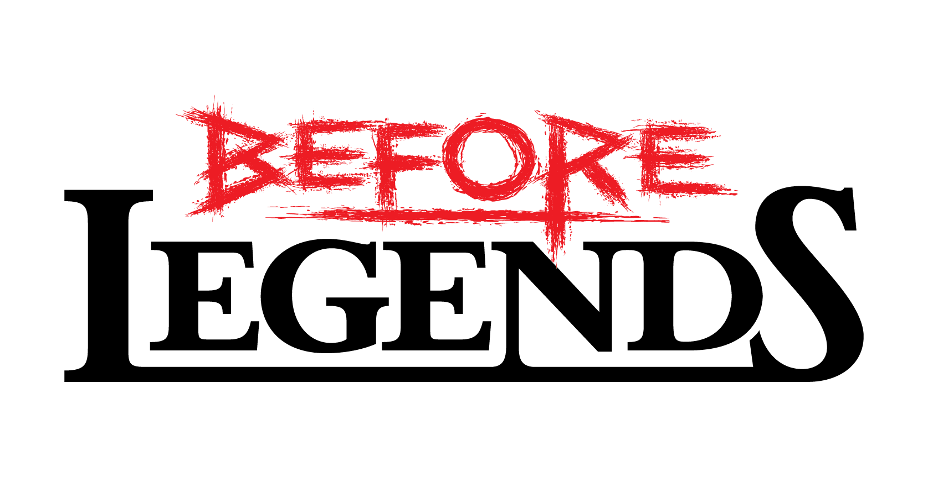

## Vision Document

## Milestone II

## 10.07.2015

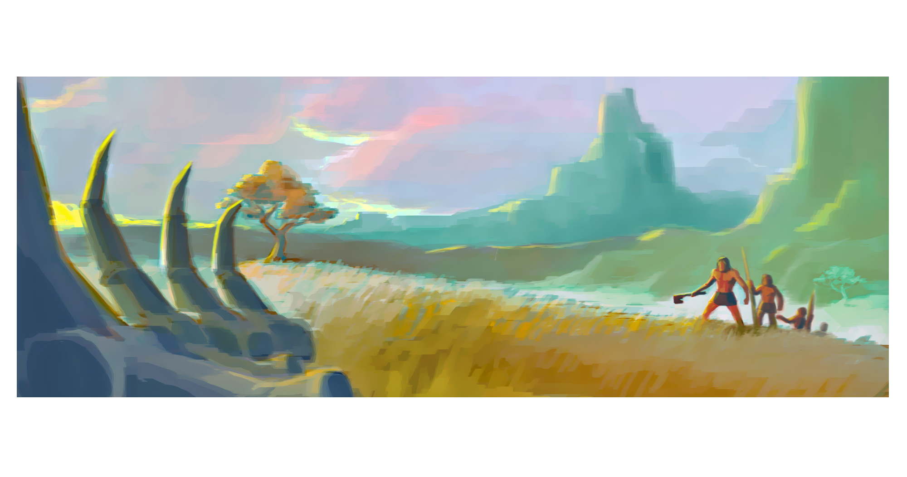

*“At the Dawn of Time the most ancient ancestors of humankind spoke with a man. Through a choir of whispers in misty dreams they revealed to him that he would change the course of history becoming the First Hero, the First Legend of Men.*

*The First hero knew that he had to confront the three biggest challenges in order to deserve the ancestors´ recognition and to get his legend to be told by the coming generations:*

*-The king of nature, the Lion, had to be defeated to prove that the First Hero can rule nature.*

*-The humanoid jackals had to be beaten to show that only humans can truly master tools and fire*

*-The Insect-Mammoth had to be slain to show that no enemy is too large or strong for the First Hero.*

*Stone axe in his hand, he began his solitary, dangerous journey.”*

Before Legends is a tactical round based exploration and survival game set in a prehistorical fantasy environment. The player moves a hero through a procedurally generated-map, gathering resources to stave off hunger and to acquire expendable battle cards. Victory is achieved through exploration and beating monsters in round based card battles.

## C:\Users\allan.cudicio\Documents\BeforeLegends\Game Design\MemoDocs\VisionDoc\Pictures\mapsettings.jpgWorld Map Exploration

In Before Legends you explore a prehistoric world through a hexagon-based map. Each map is generated procedurally at the beginning of the game´s session and each tile´s texture indicates a specific type of terrain. The player can customize the generated map preselecting size, humidity, temperature and altitude.

*Map customisation before game*

On the map you can always find two elements: resources and enemies. The resources are:

C:\Users\allan.cudicio\Documents\BeforeLegends\Game Design\MemoDocs\VisionDoc\Pictures\FoodIconReduced.png FOOD: 🡪 can be consumed to stave off hunger

C:\Users\allan.cudicio\Documents\BeforeLegends\Game Design\MemoDocs\VisionDoc\Pictures\WoodIconReduced.png WOOD 🡪 can be spent to buy battle cards

C:\Users\allan.cudicio\Documents\BeforeLegends\Game Design\MemoDocs\VisionDoc\Pictures\RockIconReduced.png STONE 🡪 can be spent to buy battle cards

C:\Users\allan.cudicio\Documents\BeforeLegends\Game Design\MemoDocs\VisionDoc\Pictures\SoulsIconReduced.pngSOULS 🡪 can be spent to buy battle cards (only if shamanic)

Stone, wood and souls can be spent in the **Card Shop**, a world map´s menu in which you can acquire new battle cards.

## Combat & Enemies

While moving around the exploration map, it is possible to fight enemies – different enemies have different movement AIs. Before Legends’ Opponent are various types of:

* horned lions: *kings of nature, cunning dangerous apex predators.*
* humanoid jackals: *the only other intelligent humanoids, capable of handling tools.*
* insect-mammoths: *the largest beasts and the greatest hunt trophies.*

Once both an opponent and the player´s character find themselves in the same hexagon tile a battle ensues. Fights are resolved in a round based **battle map** in which the player has to beat his or her enemy round by round spending the right battle cards in the best order. Tactical thinking is needed as enemies have different powers and combat behaviors. The available combat cards are:

* Attack: basic weapon hit
* Wrath: powerful blow
* Stun: enemy loses next action.
* Heal: heals up to half HP
* Revenge: reflects received damage
* Shield: absorbs next attack

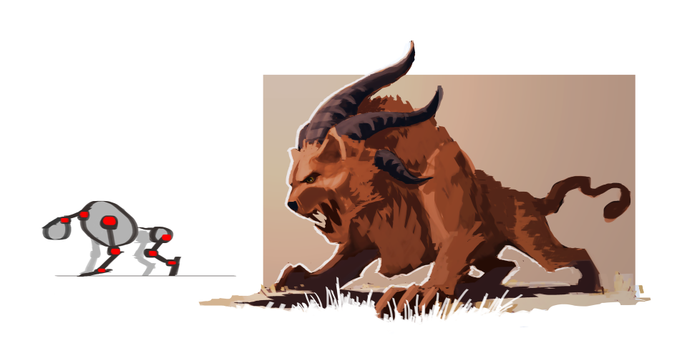

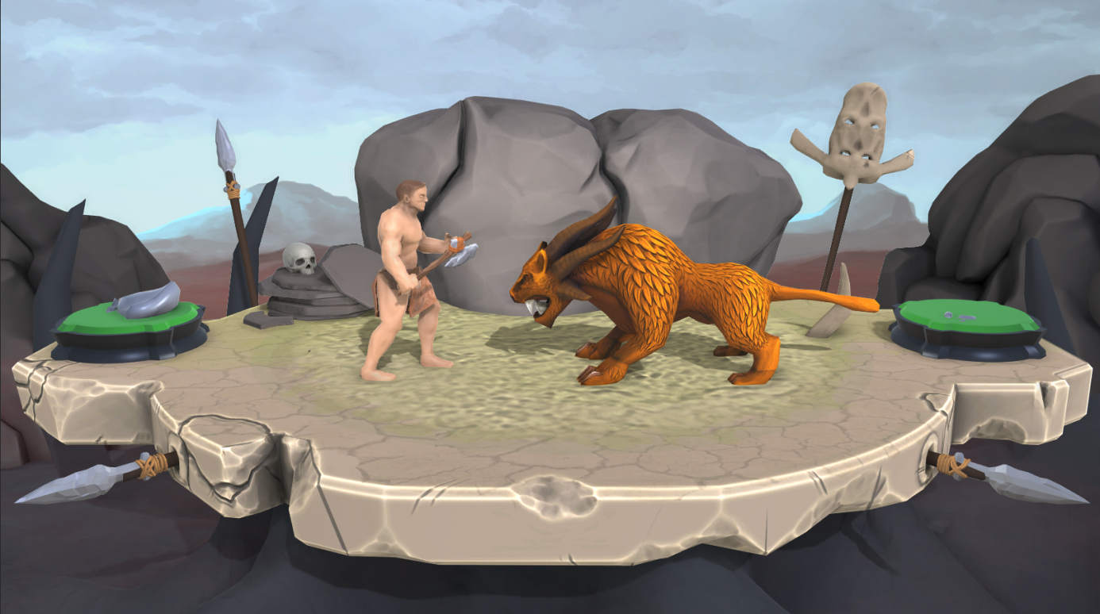

A battle scene

## Character Growth and Victory

Every time you beat an enemy in Before Legends you get food and **glory**. Glory is akin to experience points like in most roleplaying levels. Accumulating glory will allow the player to hit level advancements becoming stronger and allowing him or her to take on more powerful enemies.

Game Victory can be achieved accumulating glory and resources or through exploration.

## C:\Users\allan.cudicio\Documents\BeforeLegends\Game Design\MemoDocs\VisionDoc\Pictures\ExploMap.jpg

The Hero exploring the world map

## *The Bonfire Elders* – The team

* Allan Cudicio Game Design
* Raphael Koller 3D Art
* Amon Kalagin 3D Art
* Toma Komitski Game Design & Visionkeeping
* Benjamin Koß Code
* Viktor Pekar Production
* Andreas Pinternagel Art 2D
* Daniel Pochert Code
* Luke Ulke Code

Extern:

* Manfred Tausch Musik & SFX
* Samir Riecke 3D Art

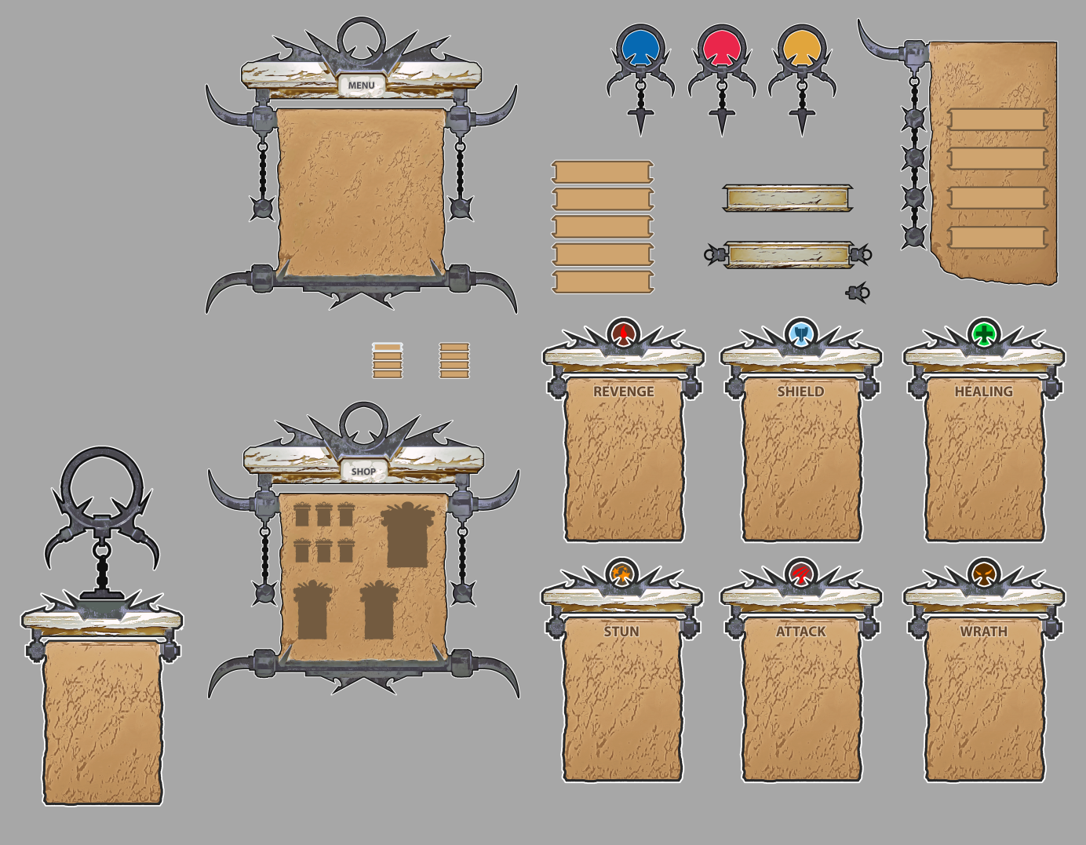

User interface design concepts